[cloudera@quickstart ~]$ hadoop fs -mkdir /user/cloudera/Brett

cloudera@quickstart ~]$ hadoop fs -put /home/cloudera/Downloads/word_list.txt /user/cloudera/Brett

[cloudera@quickstart ~]$ hadoop fs -put /home/cloudera/Downloads/shakespeare.txt /user/cloudera/Brett

[cloudera@quickstart ~]$ hadoop fs -ls /user/cloudera/Brett

Found 2 items

-rw-r--r-- 1 cloudera cloudera 5590188 2020-06-09 10:56 /user/cloudera/Brett/shakespeare.txt

-rw-r--r-- 1 cloudera cloudera 16791 2020-06-09 10:56 /user/cloudera/Brett/word_list.tx

[cloudera@quickstart ~]$ hadoop fs -cat /user/cloudera/Brett/* | hadoop fs -put - /user/cloudera/Brett/append.txt

[cloudera@quickstart ~]$ hadoop fs -cat /user/cloudera/Brett/* | hadoop fs -put - /user/cloudera/Brett/append.txt

[cloudera@quickstart ~]$ hadoop fs -ls /user/cloudera/Brett

Found 3 items

-rw-r--r-- 1 cloudera cloudera 5606979 2020-06-09 11:19 /user/cloudera/Brett/append.txt

-rw-r--r-- 1 cloudera cloudera 5590188 2020-06-09 10:56 /user/cloudera/Brett/shakespeare.txt

-rw-r--r-- 1 cloudera cloudera 16791 2020-06-09 10:56 /user/cloudera/Brett/word_list.txt

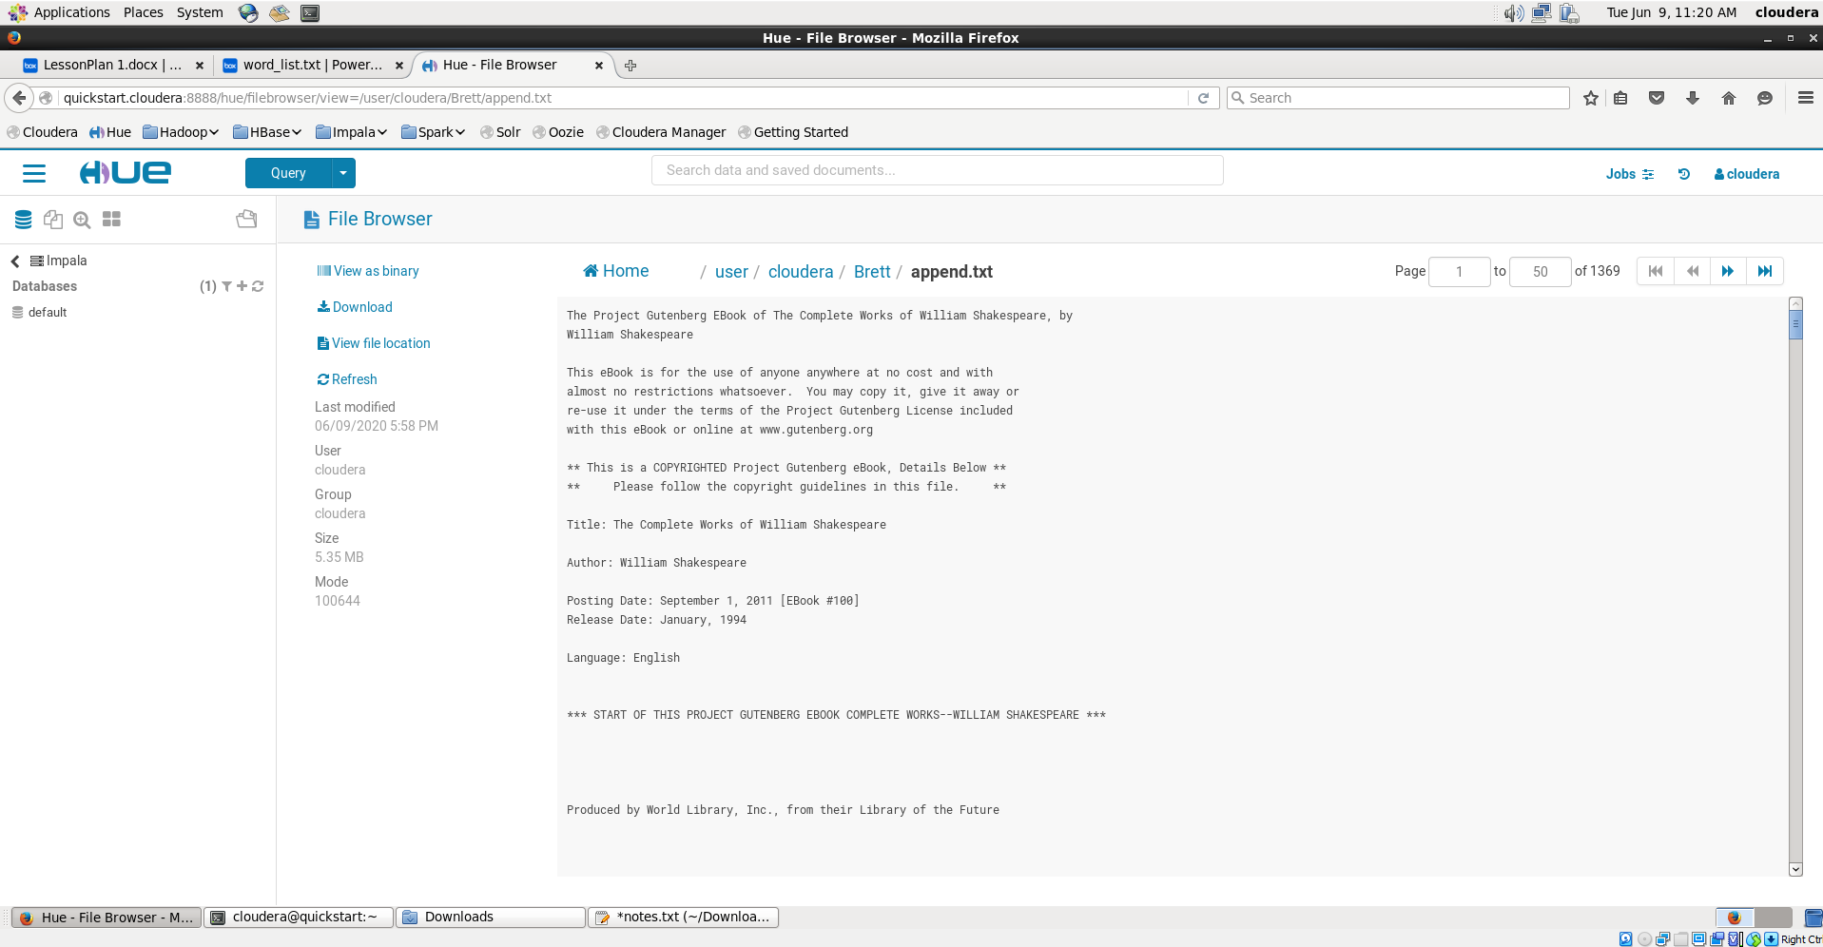

[cloudera@quickstart ~]$ hadoop fs -cat /user/cloudera/Brett/append.txt | head

The Project Gutenberg EBook of The Complete Works of William Shakespeare, by

William Shakespeare

This eBook is for the use of anyone anywhere at no cost and with

almost no restrictions whatsoever. You may copy it, give it away or

re-use it under the terms of the Project Gutenberg License included

with this eBook or online at www.gutenberg.org

** This is a COPYRIGHTED Project Gutenberg eBook, Details Below **

** Please follow the copyright guidelines in this file. **

[cloudera@quickstart ~]$ hadoop fs -cat /user/cloudera/Brett/append.txt | tail

Quick Start

1) Insure you have at least 10Mb of free disk space to hold the contents

of this zip file.

2) Create a directory to hold these files listed above.

3) Extract the contents of this zip file into the destination directory

using any compatible zip file extraction utility.

4) Delete the original zip file from your disk to save space. (optional)

End of this Project Gutenberg etext of Moby Word II by Grady Ward.

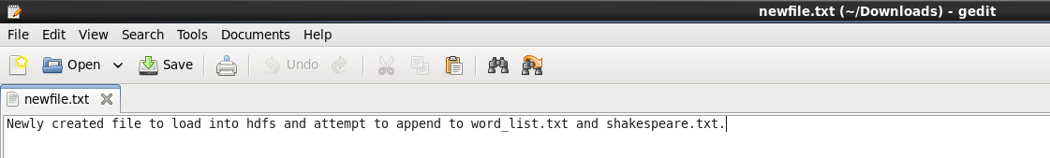

[cloudera@quickstart ~]$ hadoop fs -put

/home/cloudera/Downloads/newfile.txt /user/cloudera/Brett

[cloudera@quickstart ~]$ hadoop fs -ls /user/cloudera/Brett

Found 4 items

-rw-r--r-- 1 cloudera cloudera 5606979 2020-06-09 11:19 /user/cloudera/Brett/append.txt

-rw-r--r-- 1 cloudera cloudera 97 2020-06-09 11:26 /user/cloudera/Brett/newfile.txt

-rw-r--r-- 1 cloudera cloudera 5590188 2020-06-09 10:56 /user/cloudera/Brett/shakespeare.txt

-rw-r--r-- 1 cloudera cloudera 16791 2020-06-09 10:56 /user/cloudera/Brett/word_list.txt

[cloudera@quickstart ~]$ hdfs dfs -rm /user/cloudera/Brett/append.txt

Deleted /user/cloudera/Brett/append.txt

[cloudera@quickstart ~]$ hadoop fs -cat /user/cloudera/Brett/* | hadoop fs -put - /user/cloudera/Brett/new_append.txt

[cloudera@quickstart ~]$ hadoop fs -ls /user/cloudera/Brett

Found 4 items

-rw-r--r-- 1 cloudera cloudera 5607076 2020-06-09 11:27 /user/cloudera/Brett/new_append.txt

-rw-r--r-- 1 cloudera cloudera 97 2020-06-09 11:26 /user/cloudera/Brett/newfile.txt